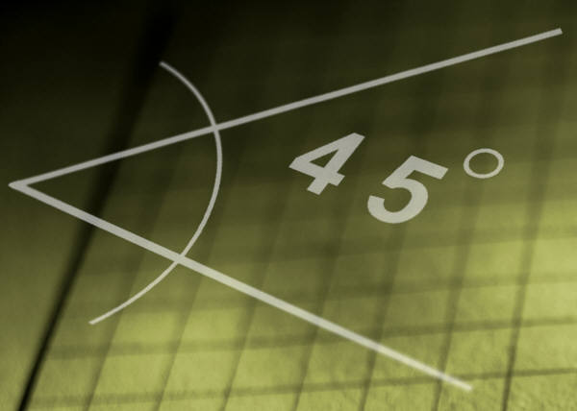
What’s the angle? 2

Materials:
Protractor
Pencil , Paper, Ruler

Procedure
- Using the ruler draw an angle.
- Label the vertex and a point on each ray.
- Using the protractor measure the angle.
T
- Name the angle and record the measurement.
- Repeat at least 5 times.
R

TRS = 30º

S

What’s the angle? 2

Materials:
Protractor
Pencil , Paper, Ruler

Procedure
- Using the ruler draw an angle.
- Label the vertex and a point on each ray.
- Using the protractor measure the angle.
T
- Name the angle and record the measurement.
- Repeat at least 5 times.
R

TRS = 30º

S

